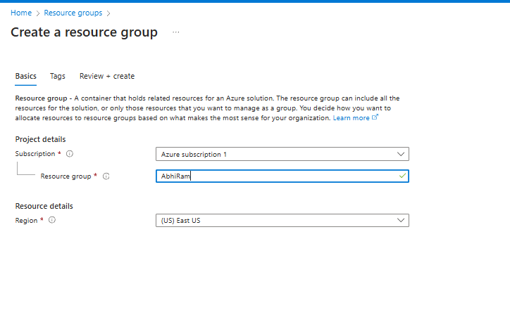

**Name – Abhiram S**

**Reg. Mail in GUVI –** [**ssabhiram411@gmail.com**](mailto:ssabhiram411@gmail.com)

**Batch - CC2WE-E**

**Project Scope:**

Create a web application, which is highly available in multiple regions, secure from web attacks, load balanced across regions using Application Gateway.

**Architecture Overview:**

* I began by creating a resource group at the location of East-US to organize all necessary resources.
* Within this group, I created two virtual machines (VMs): **VM1** was deployed in Central India, while **VM2** was set up in South India.
* After deploying the VMs, I installed Web app IIS (Internet Information Services) on both the VM’s to serve web applications.
* I then added code to each IIS server, making them serve content on a topic related to virtual machines.
* Next, I set up Application Gateway 1 in Central India and connected it to VM1, allowing it to manage incoming traffic and provide load balancing.
* I also created Application Gateway 2 in South India and connected it to VM2, ensuring proper traffic management for this region.
* After configuring the application gateways, I performed a health check on both VMs to ensure they were operational and that the application gateways were routing traffic correctly.
* Following this, I created a Traffic Manager to enable global load balancing across regions.
* I linked the IP addresses of Application Gateway 1 and Application Gateway 2 as endpoints in the Traffic Manager, allowing it to distribute traffic based on user location or health status.
* Before linking the endpoints, I configured a DNS to associate with the IP addresses of the application gateways, ensuring that user requests are correctly routed.
* Finally, I tested the entire setup by simulating traffic through the Traffic Manager to ensure that the requests were properly directed to the appropriate application gateway and Web application, confirming that the configuration was functioning as expected.
* This setup provides redundancy and high availability across multiple regions, ensuring that traffic is distributed optimally and that users experience low latency

**Project Architecture:**

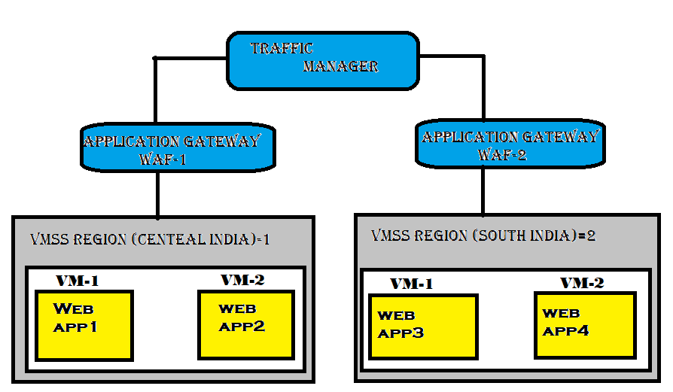

**Resource Group:**



* Created a resource group at the location of East US

**VM 1:** 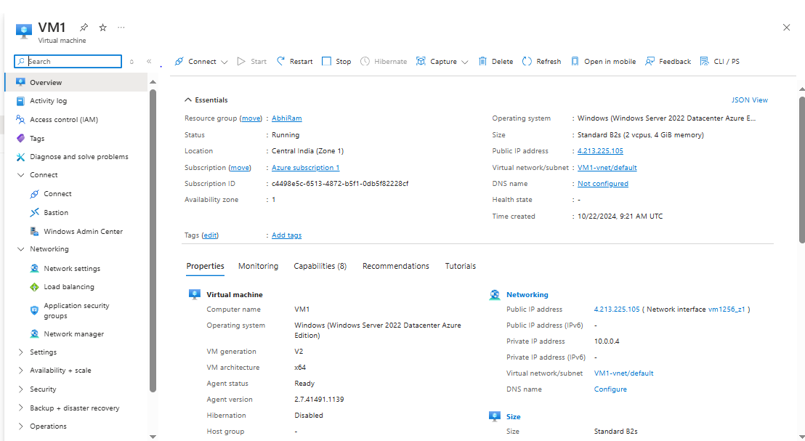

**VM 2:**

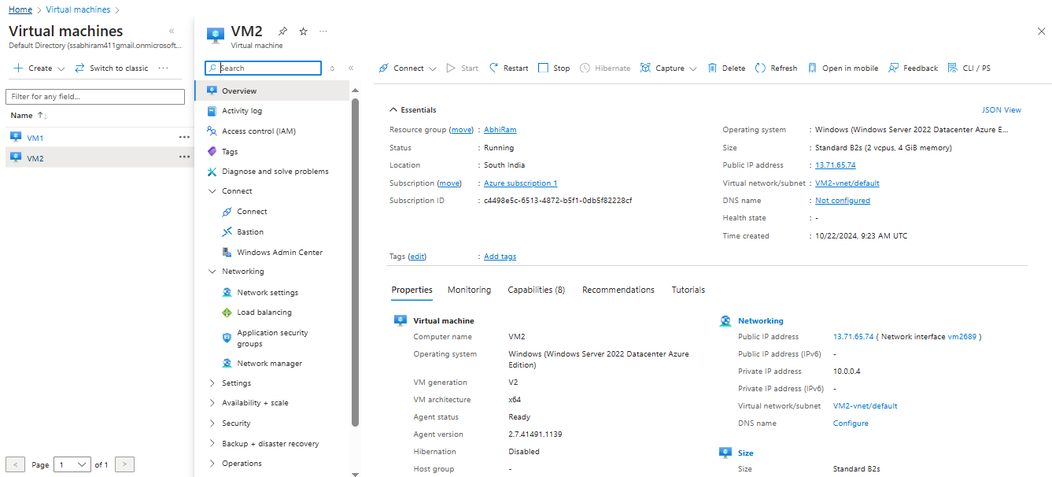

**Adding Port :**

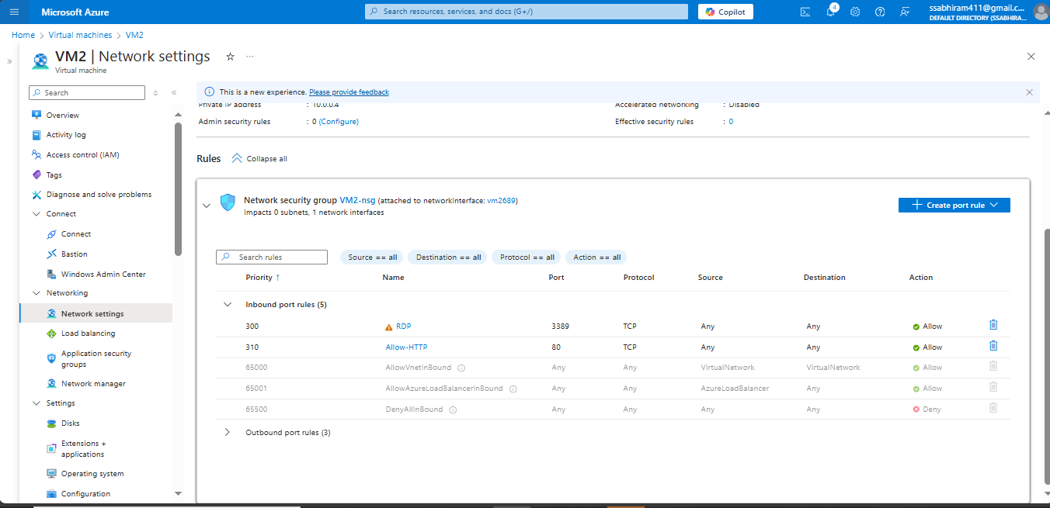

**Installing IIS:** 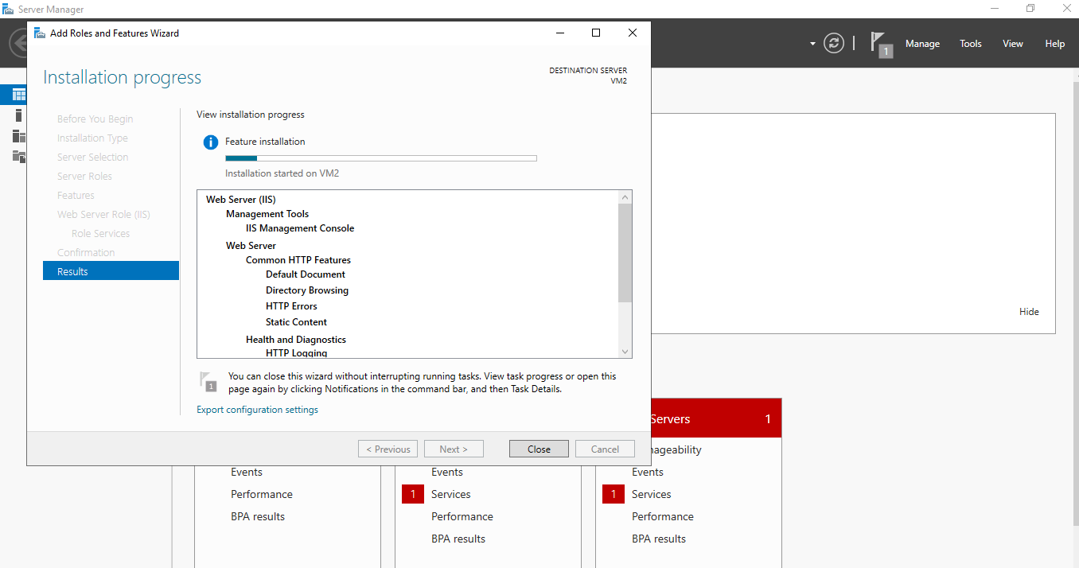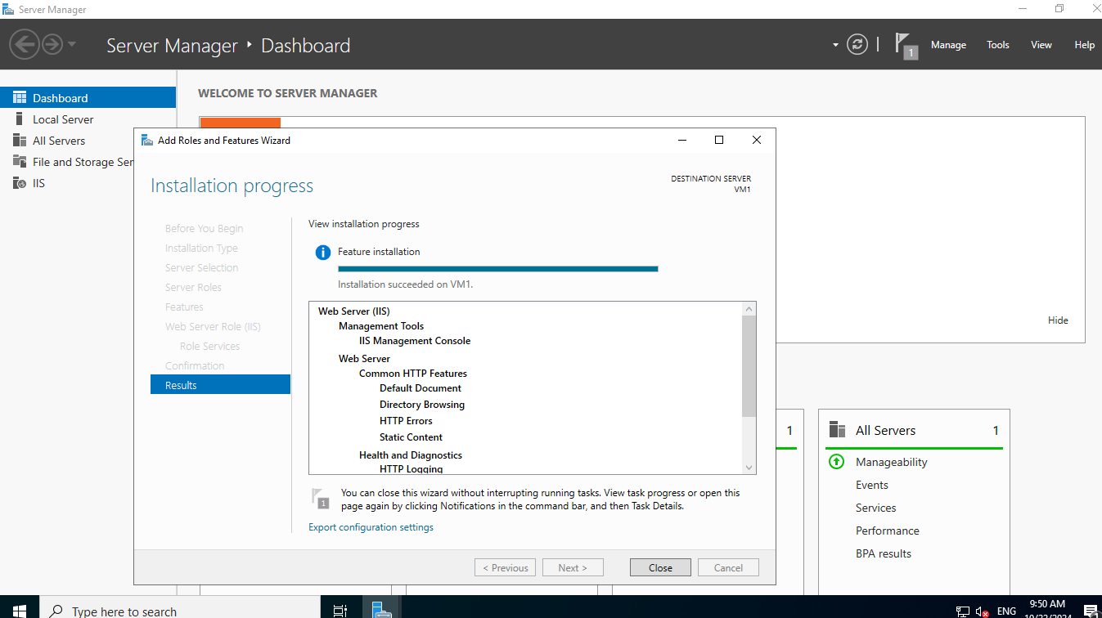

**Web App Output:**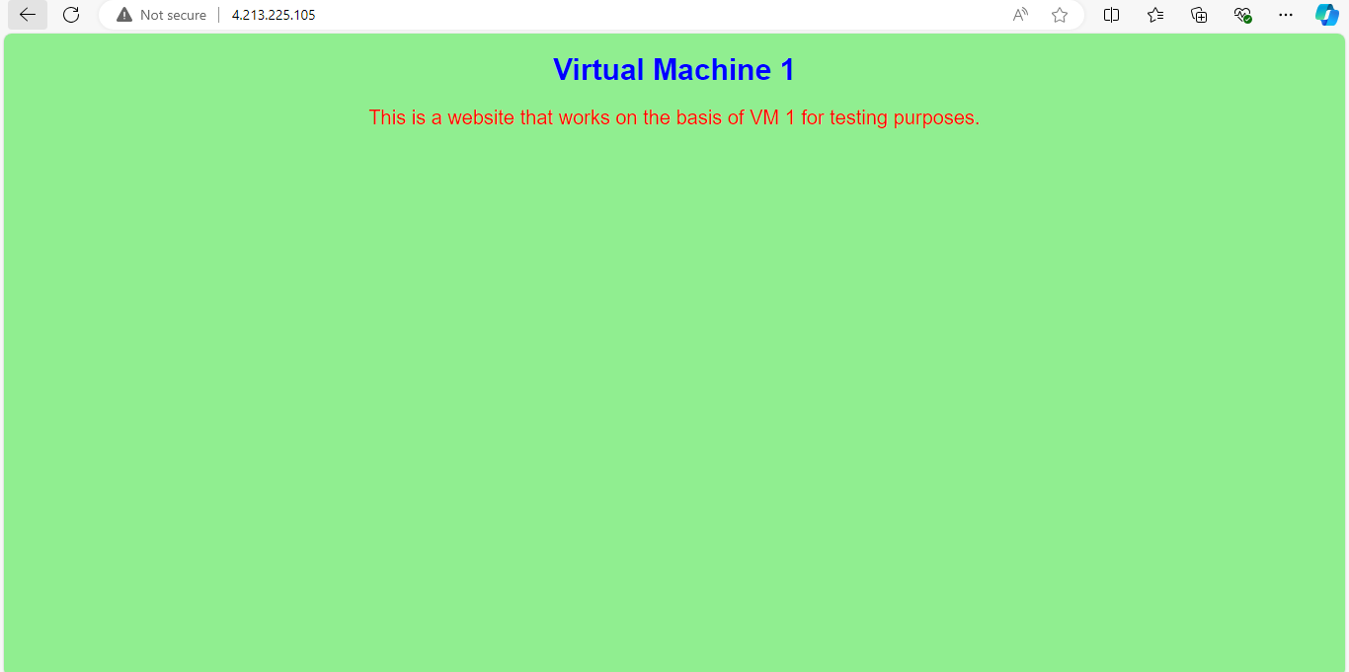

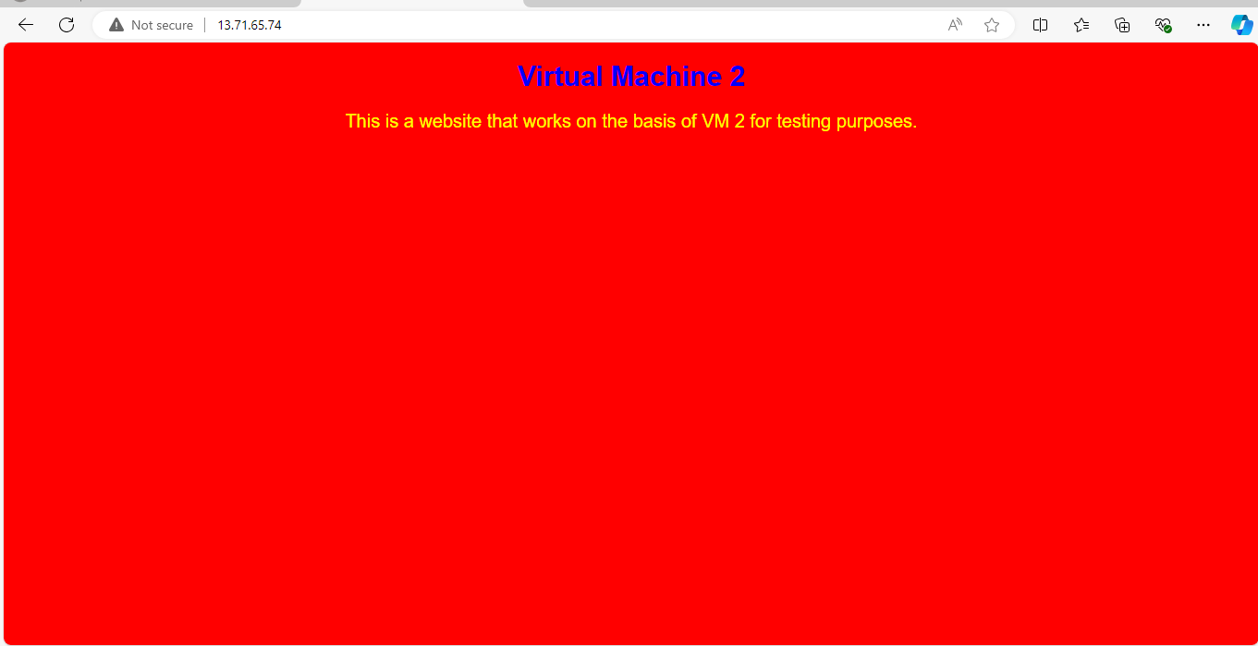

* Within this group, I created two virtual machines (VMs): **VM1** was deployed in Central India, while **VM2** was set up in South India.
* After deploying the VMs, I installed Web app IIS (Internet Information Services) on both the VM’s to serve web applications.
* I then added code to each IIS server, making them serve content on a topic related to virtual machines.

**Creating Application Gateway:**

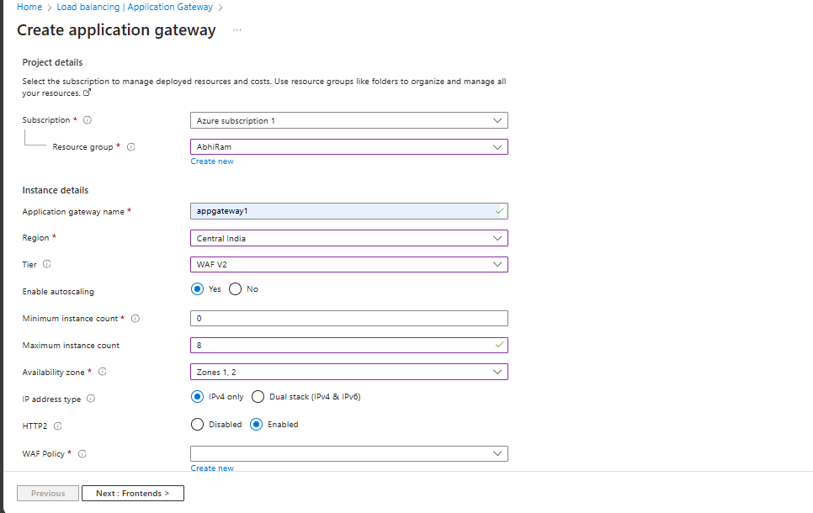

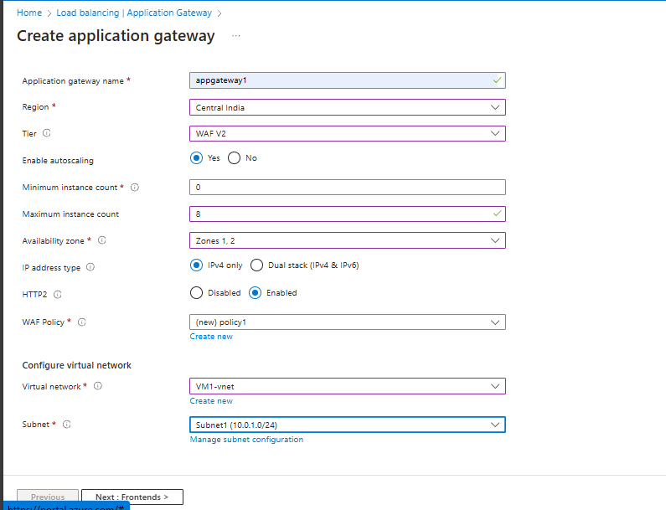

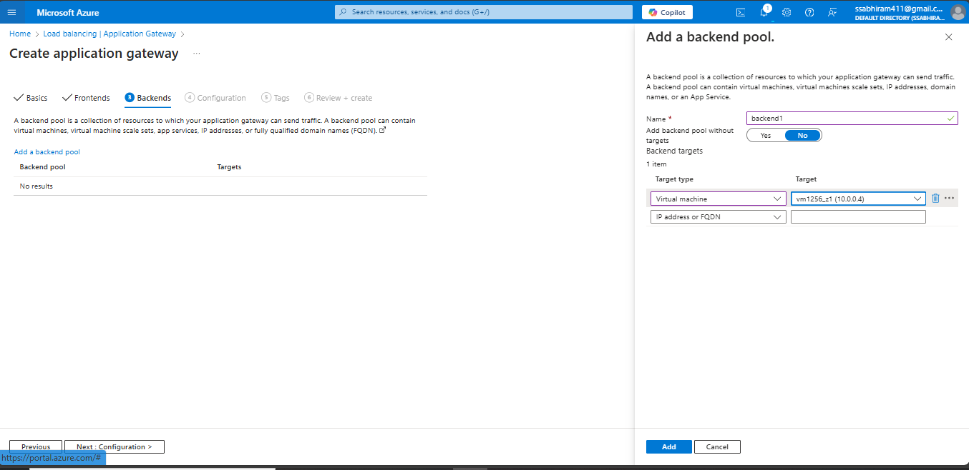

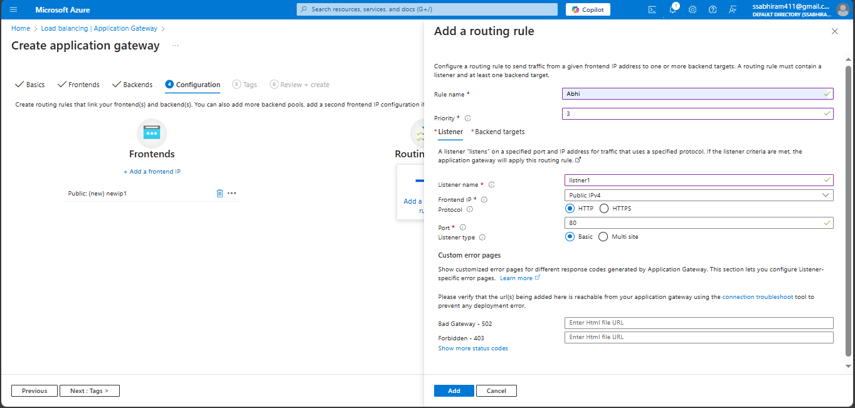

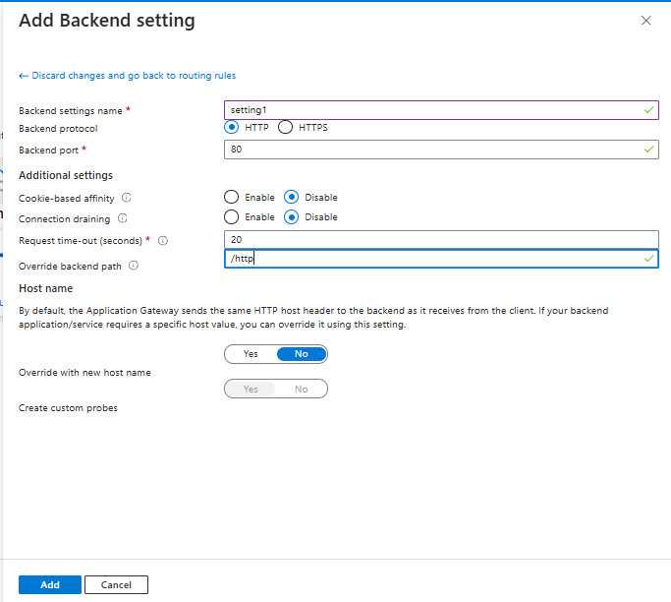

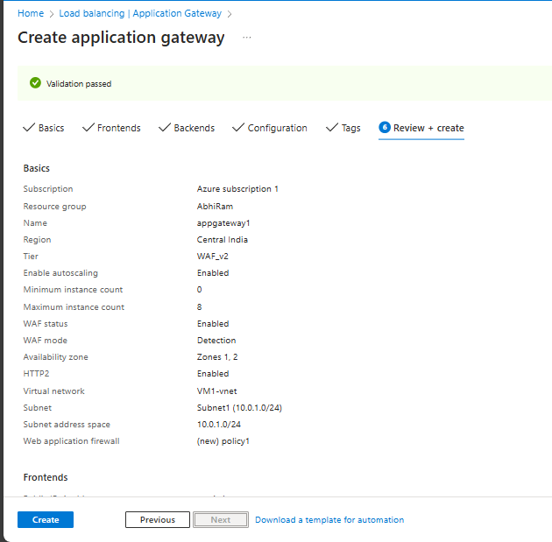

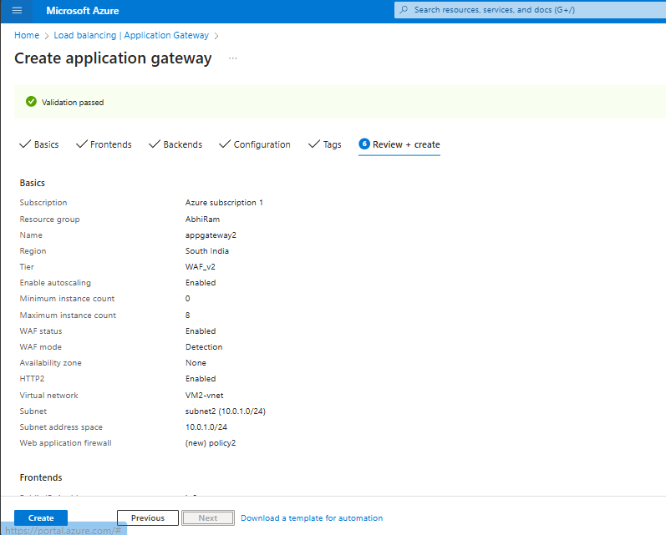

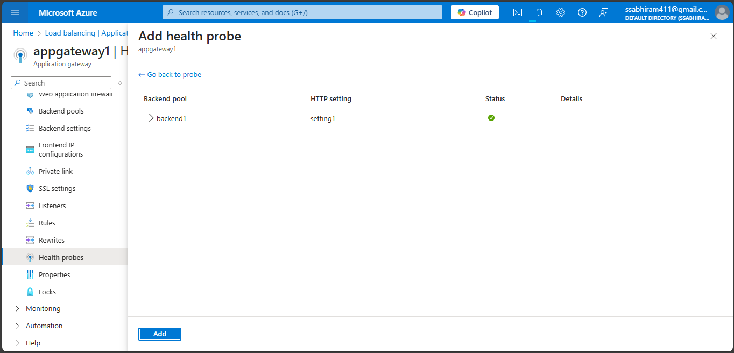

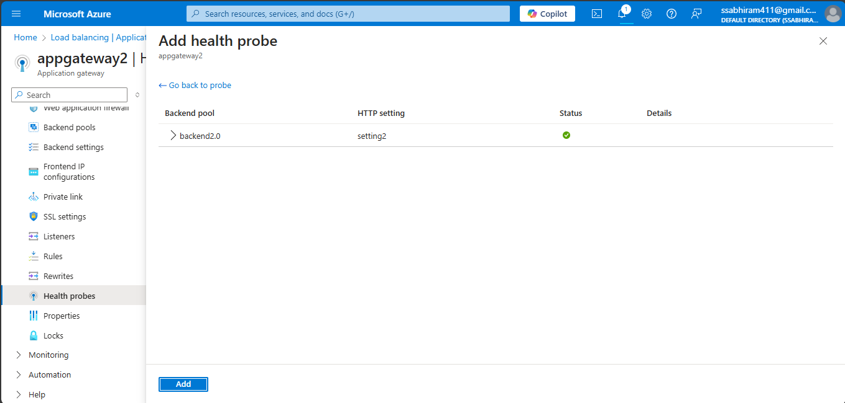

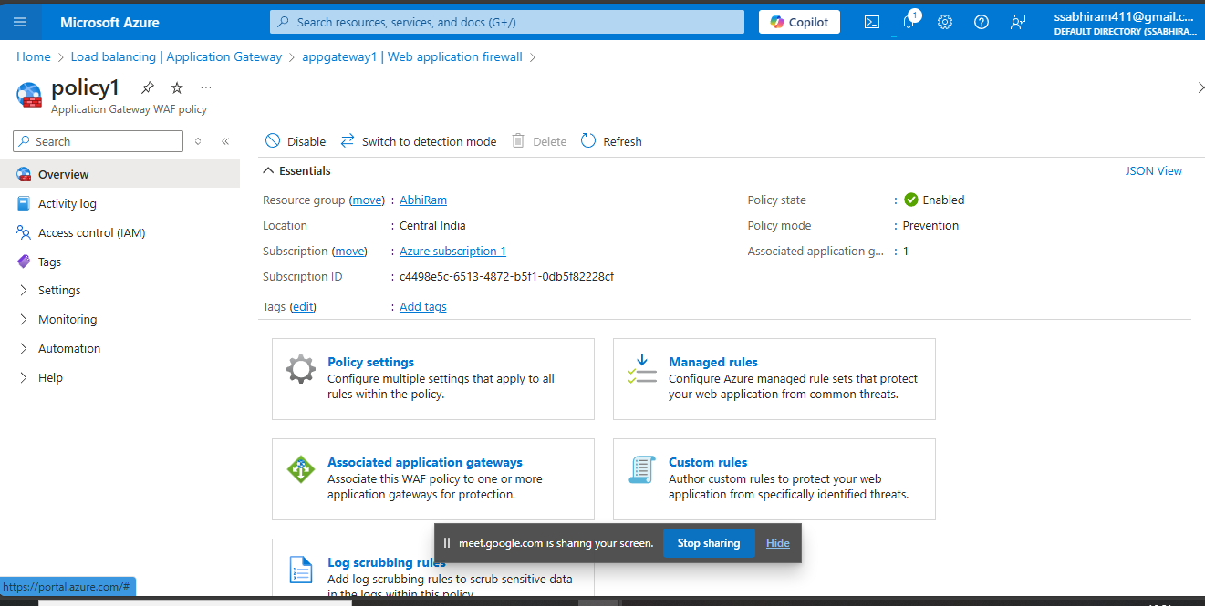

* I set up Application Gateway 1 in Central India and connected it to VM1, allowing it to manage incoming traffic and provide load balancing.
* I also created Application Gateway 2 in South India and connected it to VM2, ensuring proper traffic management for this region.
* After configuring the application gateways, I performed a health check on both VMs to ensure they were operational and that the application gateways were routing traffic correctly.

**Traficmanager:**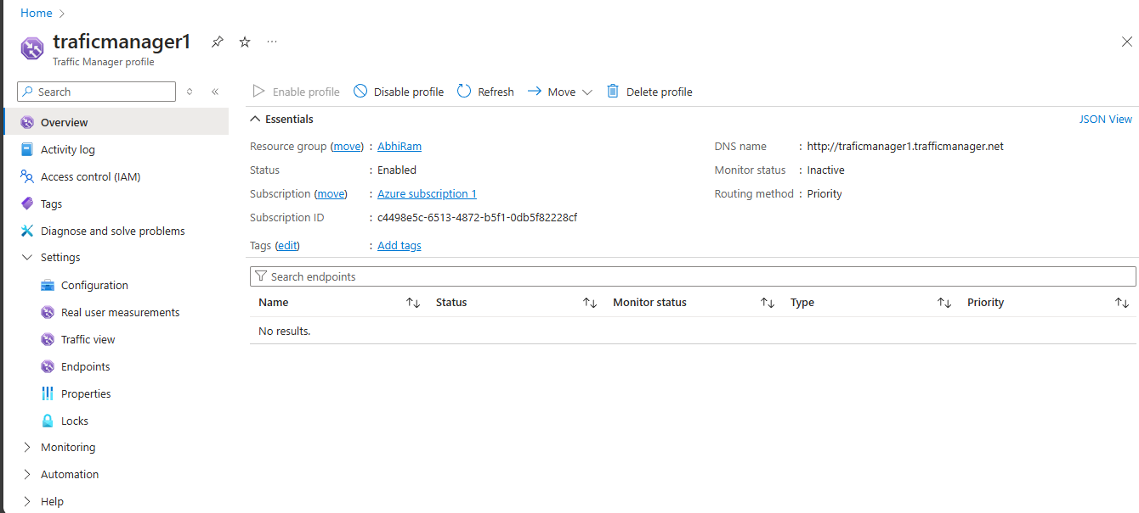

**Adding Endpoint After Connecting With The DNS:**

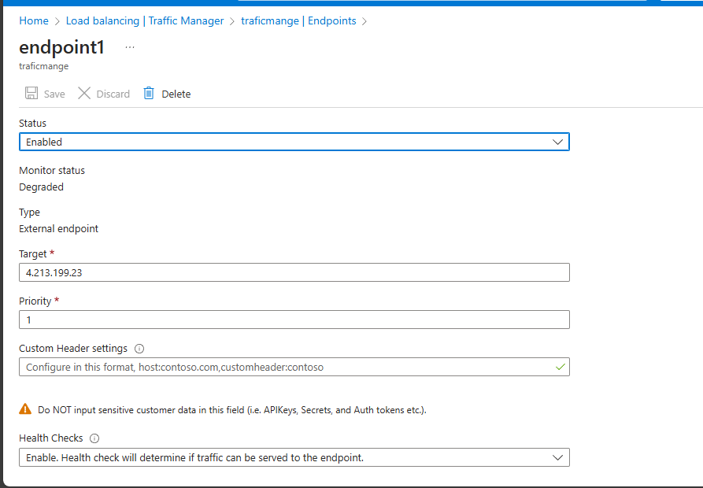

**Checking End Point Online :**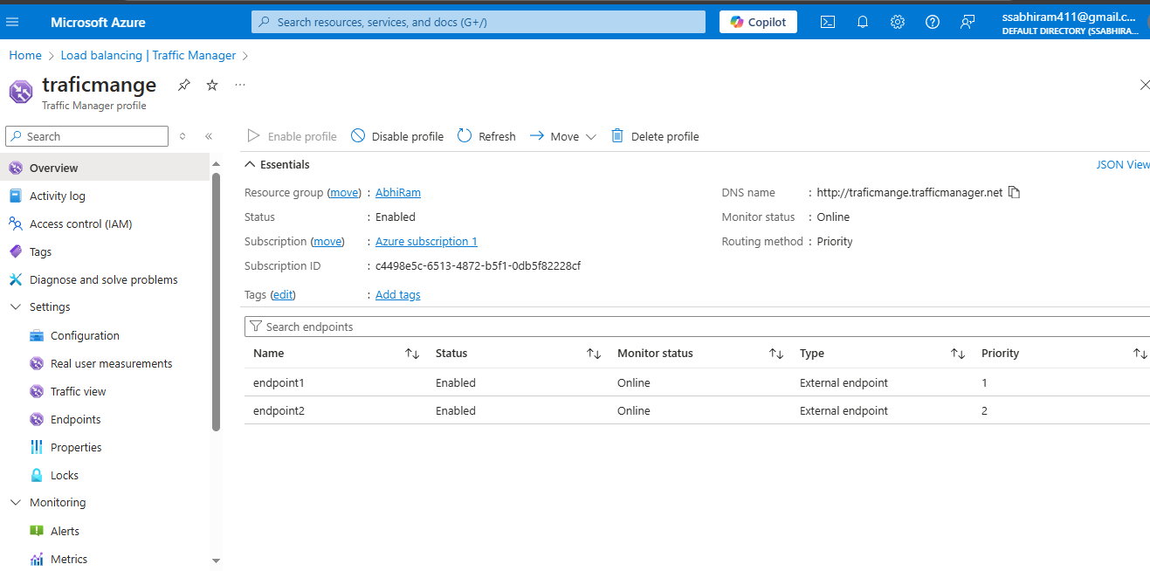

**Web app 1 Output Comes:**

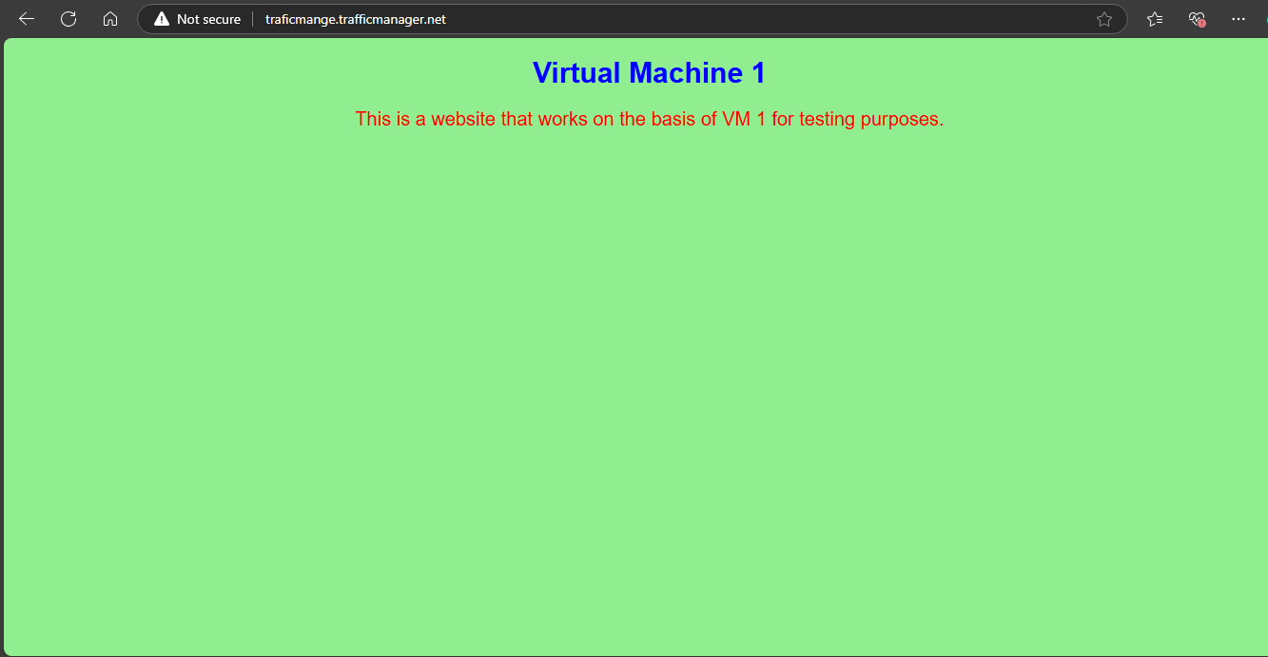

**Endpoint 1 Get Degraded:**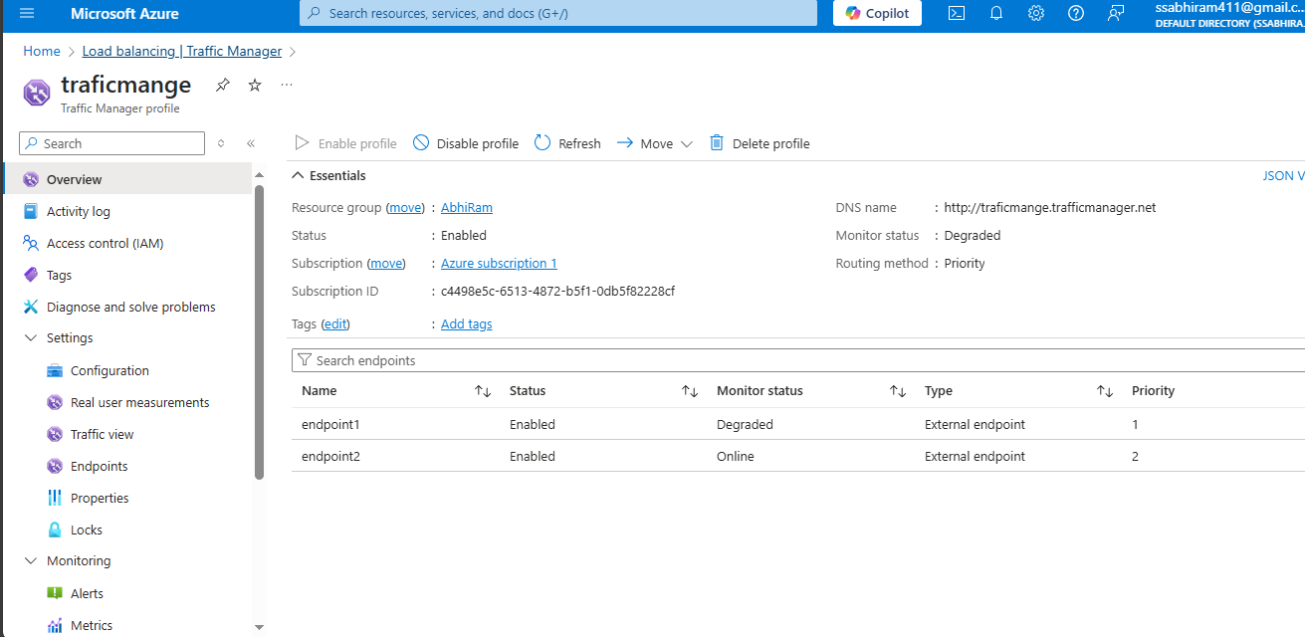

**Web App 2 Output Occurs:**

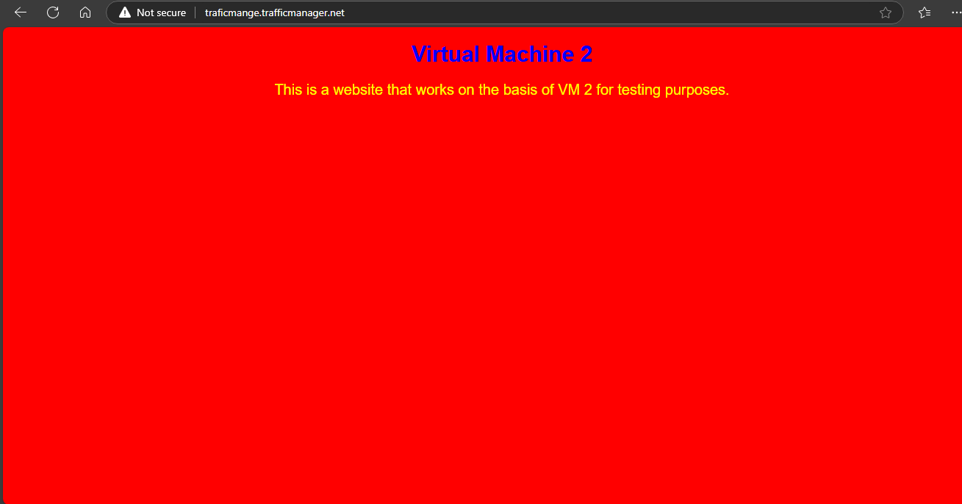

**Error in the URL:**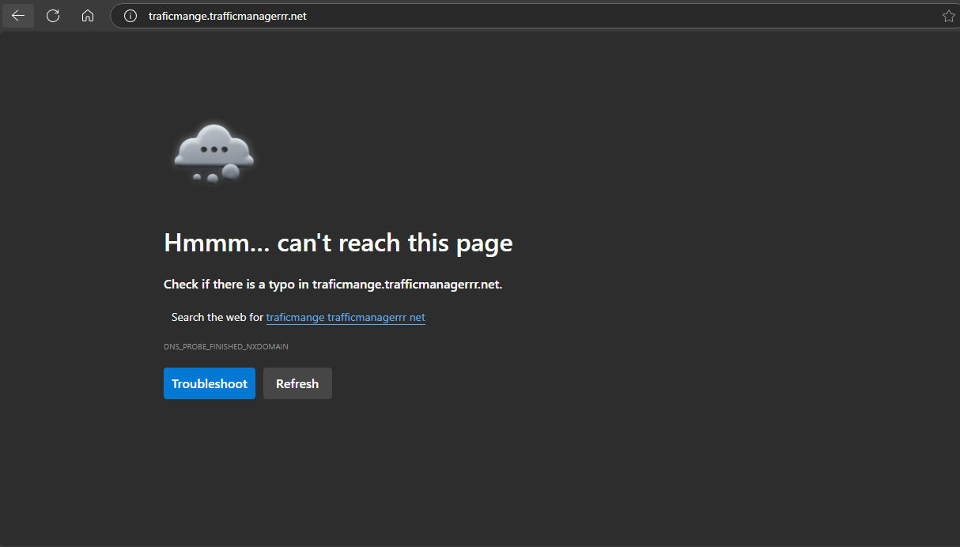

* Following this, I created a Traffic Manager to enable global load balancing across regions.
* I linked the IP addresses of Application Gateway 1 and Application Gateway 2 as endpoints in the Traffic Manager, allowing it to distribute traffic based on user location or health status.
* Before linking the endpoints, I configured a DNS to associate with the IP addresses of the application gateways, ensuring that user requests are correctly routed.
* Finally, I tested the entire setup by simulating traffic through the Traffic Manager to ensure that the requests were properly directed to the appropriate application gateway and Web application, confirming that the configuration was functioning as expected.